 |  |  |  |  |  |  |  |  | 1  11:30 Hello Visits  3:15 Montessori
2
11:30 Story Reading (Goldblatt)
2:15 Bingo (GB)
3  10:30 Obie Game (OK)  2:30 Café Time (Bubbi Bessie’s Café)  3:30 Hello Visits  4:15 Montessori  6:30 Bowling Night |  | 4  10:30 Snoezelen (OK)  12:00 Valentino’s Take Out Lunch  2:30 Stretch & Strengthen (GB)  4:15 Montessori  6:30 Dance Club with Kyle (2nd Floor) | 5  10:30 Burlington Mall Outing  2:30 Knit and Chat (1st Floor Sunroom)  3:00 Scrabble (GD)  4:00 Montessori  6:30 Trivia Night |  | 6  10:30 Stretch & Strengthen (GB)  11:15 Story Reading  11:15 Ask the Rabbi  2:15 Bingo (GB)  3:15 Doll Therapy for Joy & Connection  6:30 Hot Chocolate (Cart) |  | 7  10:30 Bible Study (Bistro)  11:15 Relaxing Music  2:30 Making Challah Bread (OK)  3:15 Wine Time |  | 8  1130 Walking Club  3:15 Coffee & Tea Cart
9
11:30 Hello Visits
2:00 Non-Denominational Services (Goldies)
10  10:30 Stretch & Strengthen (GB)  11:15 Relaxing Music  2:30 Café Time (Bubbi Bessie’s Café)  4:15 Montessori  6:30 Pub Night featuring Andrew Bentham Biley (Goldies) |  | 11  10:30 Snoezelen (OK)  11:15 Relaxing Music  2:30 Crown Making for Purim (Theatre)  4:15 Montessori  5:30 Soup Making (Goldies) | 12  10:30 Indigo Outing  2:30 Baking Hamentaschen (Theatre)  3:00 Scrabble (GD)  4:00 Montessori  6:30 Card Games (Sunroom) |  | 13 Fast of Ester  10:30 Stretch & Strengthen ( GB)  11:15 Hello Visits  2:15 Bingo (GB)  3:15 Doll Therapy for Joy & Connection  6:30 Musical Memories |  | 14 PURIM  10:30 Reading of the Megillah (Synagogue)  2:30 Purim Parade  3:30 Wine |  | 15  11:30 Walking Club  3:15 Hello Visits
16
11:30 Hello Visits
12:30 Happy Birthday Rita (GD)
2:15 Bingo (GB)
17  10;30 Kehila Kids (Bistro)  2:30 Bingo (GB)  4:15 Montessori  6:30 Treat Cart |  | 18  10:30 Stretch & Strengthen (GB)  11:15 Relaxing Music  2:30 Travel Talk Portugal (OK)  3:15 Hello Visits  4:15 Montessori  6:30 Dance Club with Kyle (2nd Floor) | 19  10:30 Book Club with Kyle (GD)  11:30 Walking Club  12:00 Happy Birthday Steve (GB)  2:30 Sing with Paula (Bubbi Bessie’s Café)  3:00 Scrabble (GD)  4:00 Montessori  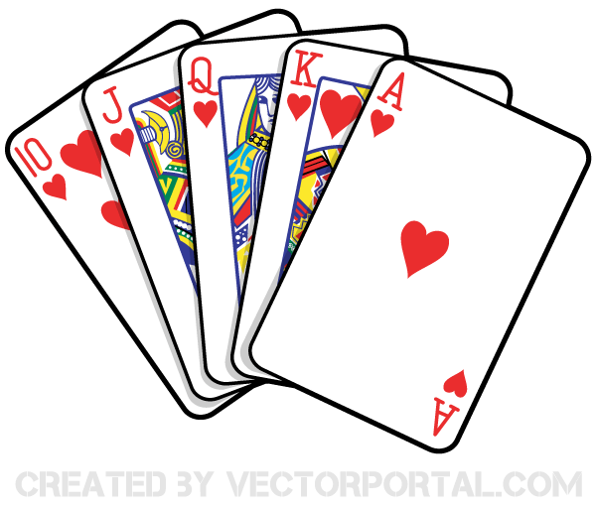  6:30 Puzzle Night |  | 20  10:30 Farmer’s Market Outing  11:15 Ask the Rabbi  2:15 Bingo (GB)  3:15 Doll Therapy for Joy & Connection  6:30 Hot Chocolate Cart |  | 21  10:30 Obie Game (OK)  11:15 Story Reading  2:15 Hello Visits  3:00 Preshabbat with Rabbi Beni (Synagogue) |  | 22  10:30 Shabbat Services (Synagogue) followed by Kiddush Lunch (Goldies)  3:15 Montessori
23
11:30 Stretch & Strengthen (GB)
2:15 Bingo (GB)
24  10:30 Milo the Cat Visits  11:15 Relaxing Music  2:15 Café Time (Bubby Bessie’s)  3:30 Hello Visits  4:15 Montessori  6:30 Bowling Night |  | 25  10:30 Hym Sing (Theatre)  11:15 Story Reading  2:30 Movie Afternoon ( Theatre)  4:15 Montessori  6:30 Dance Club with Kyle (2nd Floor) | 26  10:30 Snoezelen (OK)  11:30 Zen Time  2:30 Sing with Judy (Bubbi Bessie’s Café)  3:00 Scrabble (GD)  4:00 Montessori  6:30 Name that Tune | 27  10:30 Obie Game (OK)  11:15 Ask the Rabbi  11:30 Hello Visits  2:15 Bingo (GB)  3:15 Doll Therapy for Joy & Connection  6:30 Tea & Chat (GB) |  | 28  10:30 Snoezelen (OK)  11:15 Walking Club  2:15 Hello Visits  3:00 Preshabbat Services with Cantor Paula (Synagogue) |  | 29  11:30 Walking Club  3:15 Montessori
30
10:30 Stretch & Strengthen (GB)
2:15 Bingo
 | 31  10:30 Resident’s Council (OK)  10:30 Snoezelen (OK)  11:00 Food Committee (OK)  2:15 Café Time (Bubbi Bessie’s Café)  3:30 Hello Visits  4:15 Montessori  6:30 Musical Memories | Legend:  SVO  GD-Gould  GB –Goldblatt  ZK-Zucker  WZ-Weisz

