 |  |  |  |  |  |  |  | 1  10:30 Hello Visits  3:15 Montessori
2
10:30 Hello Visits
3:15 Bingo (WZ)
3  10:30 Stretch Strengthen Zucker  11:30 Hello Visits  2:30 Café Time (Bubbi Bessie’s Café)  6:30 Bowling Night | 4  10:30 Story Reading  11:15 Walking Club  2:30 Knit & Chat (1st Floor Sunroom)  6:30 Dance Club with Kyle (2nd Floor) | 5  10:30 Book Club with Kyle (GD)  11:30 Hello Visits  12:30 Happy Birthday David!  2:30 Art Afternoon (Sunroom)  3:00 Scrabble (GD)  6:30 Trivia Night |  | 6  10:30 Snoezelen (OK)  11:15 Story Reading  11:15 Ask the Rabbi  12:30 Happy Birthday Ruth!  2:15 Bingo (WZ)  3:30 Montessori  6:30 Hot Chocolate (Cart) |  | 7  10:30 Indigo Outing  11:30 Hello Visits  2:30 Challah Baking (Oak Knoll) |  | 8  10:30 Montessori  2 15 Coffee & Tea Cart
9
10:30 Stretch & Strengthen (Goldblatt)
2:00 Non-Denominational Services (Goldies)
10  10:30 Burlington Mall  2:30 Café Time (Bubbi Bessie’s Café)  6:30 Musical Memories | 11  10:30 Sweetheart Card Making (GB)  11:30 Relaxing Music  2:30 Movie Afternoon (Classic Theatre)  6:30 Dance Club with Kyle (2nd Floor) | 12  10:30 Kehila Kids (Bistro)  11:15 Hello Visits  2:30 Story Reading  3:30 Montessori  6:30 Card Games (Sunroom) |  | 13 Tu B’Shevat  10:30 Tu B’Shevat Service (Synagogue)  11:15 Hello Visits  2:15 Bingo (WZ)  3:30 Montessori  6:30 Treat Cart |  | 14  10:30 Snoezelen (OK)  11:15 Relaxing Music  2:30 Sweet Heart Celebration (Bistro) |  | 15  10:30 Shabbat Services (Synagogue) followed by Kiddush Lunch (Goldies)  2:30 Hello Visits
16
10:30 Walking Club
3:15 Bingo (WZ)
17  10:30 Black History Month  (Presentation ) Zucker  11:15 Walking Club  2:30 Bingo (WZ)  6:30 Bowling Night | 18  10:30 Wall Mart  2:30 Travel Talk Puerto – Rico Oak Knoll)  2:30 Snoezelon  6:30 Dance Club with Kyle (2nd Floor) | 19  10:30 Hymn Sing with Rebeca (FDR)  11:30 Zen Time (GB)  2:30 Sing with Judy (Bubbi Bessie’s Café)  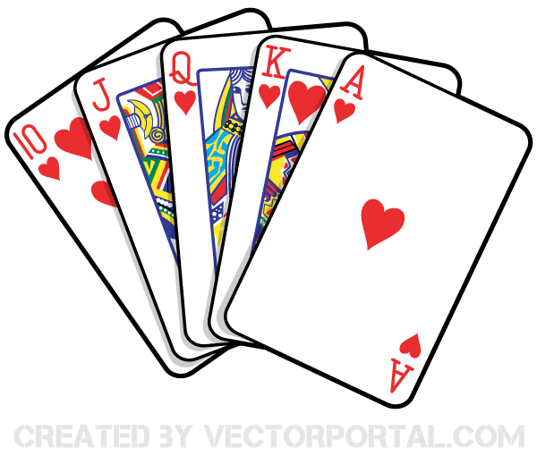  6:30 Puzzle Night |  | 20  10:30 Stretch & Strengthen  11:15 Ask the Rabbi  11:15 Relaxing Music  2:15 Bingo (WZ)  3:30 Montessori  6:30 Hot Chocolate Cart |  | 21  10:30 Bible Study (FDR)  2:00 Hello Visits  3 PM Preshabbat with Rabbi Beni |  | 22  10;00 Ohex Zedeh Service (Synagogue)  3:15 Montessori
23
10;30 Stretch & Strengthen (GB)
3:15 Bingo (WZ)
24  10:30 Snoezelen (OK)  11:15 Relaxing Music  2:15 Café Time (Bubby Bessie’s)  3:30 Hello Visits  6:30 Treat Cart | 25  10:30 Winter Cruise  2:30 Fruit Crumble (GB)  6:30 Dance Club with Kyle (2nd Floor) | 26  10:30 Book Club with Kyle (GD)  11:30 Zen Time  2:30 Musical Memories (GB)  6:30 Card Games (Sunroom) | 27  10:30 Resident’s Council (OK)  10:30 Armchair Travel with Madeline (GB)  11:15 Ask the Rabbi  11:00 Food Committee (OK)  2:15 Bingo (WZ)  3:30 Montessori  6:30 Treat Cart |  | 28  10:30 Snoezelen (OK)  11:15 Relaxing Music  2:00 Hello Visits  3:00 Preshabbat Services (Synagogue) with Cantor Paula

