 |  |  |  |  |  |  |  | 1  11:30 Hello Visits  12:00 Happy Birthday Arno! (RC)  3:15 Montessori
2
10:30 Stretch & Strengthen (RC Alcove)
2:30 Combined Bingo (RC)
3  10:30 Obie Game(OK)  11:30 Hello Visits  2:30 Short Stories (OK)  3:45 Montessori  6:30 Coffee Cart | 4  10:30 Burlington Mall Outing  2:30 Musical Memories (OK)  6:30 Treat Cart | 5  10:30 Snoezelen (OK)  11:15 Hello Visits  2:15 Cafe Time (Bubbi Bessie’s)  4:15 Montessori  6:30 Trivia Night (OK) |  | 6  10:30 In-Style Seniors with Diana (OK)  11:15 Zen Time  11:15 Ask the Rabbi  2:15 Bingo (RC)  3:30 Hello Visits |  | 7  10:30 Bible Study with Rebeca (Samuel’s Bistro)  2:30 Challah Baking (OK)  3:30 Wine  4:15 Montessori  6:30 Tea & Chat (OK) |  | 8  11:30 Montessori  2:00 Walking Club
9
11:30 Hello Visits
2:00 Non-Denominational Church Services (Goldie’s)

10  10:30 Kehila Kids (Bistro)  11:30 Hello Visits  12:30 Happy Birthday Judy!  2:30 Rummoli (RC)  3:45 Montessori  6:30 Pub Night ft., Andrew Bentham Riley (Goldie’s) | 11  10:30 Indigo Outing  2:30 Crown Making for Purim (Theatre)  5:30 Soup Making (Goldie’s) | 12  10:30 Snoezelen (OK)  11:15 Hello Visits  2:30 Baking Hamentsachen (Theatre)  4:15 Montessori  6:30 Musical Memories (OK) |  | 13 Fast of Esther  10:30 In-Style Seniors with Diana (OK)  10:30 Spa Morning  11:15 Ask the Rabbi  2:15 Bingo (RC)  3:30 Hello Visits |  | 14 Purim  10:30 Reading the Melilla (Synagogue)  11:30 Hello Visits  2:30 Purim Parade  3:45 Wine  4:15 Montessori  6:30 Tea & Chat (OK) |  | 15  11:30 Montessori  3:00 Coffee Cart
16
11:30 Walking Club
2:30 Combined Bingo (RC)
17  10:30 Stretch & Strengthen (Alcove)  12:00 Chinese Take-Out (Potting Shed)  2:30 Musical Memories  3:45 Montessori  6:30 Movie Night (OK) | 18  10:30 Stretch & Strengthen (Alcove )  2:30 Travel Talk: Portugal (OK)  6:30 Musical Memories (OK) | 19  10:30 Snoezelen (OK)  11:15 Zen Time (RC)  2:30 Sing with Paula (Bubbi Bessie’s Café)  4:15 Montessori  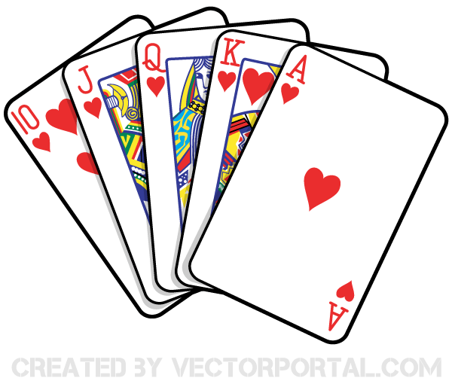  6:30 Card Games (OK) |  | 20  10:30 In-Style Seniors with Diana (OK)  11:15 Relaxing Music  11:15 Ask the Rabbi  2:15 Bingo (RC)  3:30 Hello Visits |  | 21  10:30 Obie Games (OK)  2:00 Hello Visits  3:00 Pre-Shabbat with Rabbi Beni (Synagogue)  4:15 Montessori  6:30 Tea & Chat (OK) |  | 22  10:30 Shabbat Services (Synagogue) followed by Kiddush Lunch (Goldie’s)  3:15 Hello Visits
23
10:30 Stretch & Strengthen (RC Alcove)
2:30 Combined Bingo (RC)
24  10:30 Snoezelen  11:15 Visits with Milo the Cat  2:15 Trivia (OK)  3:45 Montessori  6:30 Musical Memories (Alcove) | 25  10:30 Hymn Sing ( Classic Theatre )  11:15 Montessori  2:30 Movie Afternoon (Classic Theatre)  6:30 Treat Cart | 26  10:30 Stretch & Strengthen (OK)  11:15 Relaxing Music  12:30 Happy Birthday Alan! (MP)  2:15 Sing with Judy Cafe Time (Bubbi Bessie’s)  4:15 Montessori  6:30 Hot Chocolate Cart | 27  10:30 Obie Games (OK)  10:30 In-Style Seniors with Diana (RC)  11:15 Ask the Rabbi  2:15 Bingo (RC)  3:30 Hello Visits |  | 28  10:30 Farmer’s Market Outing  2:15 Hello Visits  3:00 Pre-Shabbat with Cantor Paula (Synagogue)  4:15 Montessori  6:30 Tea & Chat (OK) |  | 29  11:30 Hello Visits  12:00 Happy Birthday Albert! (RC)  2:30 Walking Club
30
11:15 Montessori
12:00 Happy Birthday Bronya! (RC)
2:30 Combined Bingo (RC)
31 10:30 Resident’s Council (OK)
11:00 Food Committee
2:15 Pizza Making (OK)
3:45 Montessori
6:30 Bowling (OK)

