 |  | 1 New Year’s Day  10:30 Book Club with Kyle (GD)  11:30 Hello Visits  2:30 Art Afternoon (GB)  3:00 Scrabble (GD)  4:00 Montessori  6:30 Trivia (GB) |  | 2  10:30 Snoezelen (OK)  11:15 Story Reading  11:15 Ask the Rabbi  2:15 Bingo (GB)  3:30 Piano Concert with Tsylia  6:30 Hot Chocolate Cart |  | 3  10:30 Stretch & Strengthen (GB)  Noon Happy Birthday Stewart  11:15 Zen Time  2:15 Bingo (GB)  3:15 Wine Time |  | 4  11:15 Hello Visits  12:30 Happy Birthday Shirley (GD)  3:15 Montessori
5
11:15 Hello Visits
2:15 Bingo (GB)
6  10:30 Stretch & Strengthen (GB)  11:15 Zen Time  2:30 Café Time (Bubbi Bessie’s Café)  4:15 Montessori  6:30 Bowling Night | 7  10:30 Walking Club  11:15 Relaxing Music  2:30 Travel Talk- Australia (OK)  4:15 Montessori  6:30 Dance Club with Kyle (2nd Floor) | 8  10:30 Book Club with Kyle (GD)  11:30 Hello Visits  2:15 Sing with Judy (Bubbi Bessie’s Café)  3:00 Scrabble (GD)  4:00 Montessori  6:30 Card Games (GB) |  | 9  10:30 Snoezelen (OK)  11:15 Story Reading  11:15 Ask the Rabbi  2:15 Bingo (GB)  3:30 Piano Concert with Tsylia  6:30 Hot chocolate (Cart) |  | 10  10:30 Stretch & Strengthen (GB)  11:15 Relaxing Music  2:15 Bingo (GB)  3:15 Wine Time |  | 11  11:15 Hello Visits  3:15 Montessori
12
11;30 Hello Visits
2:00 Non-Denominational Services (Goldies)
13  10:30 Stretch & Strengthen (GB)  11:15 Relaxing Music  12:00 Happy Birthday Mania (GB)  2:30 Café Time (Bubbi Bessie’s Café)  4:15 Montessori  6:30 Pub Night featuring Paula French (Bubbi Bessie’s Café) | 14  10:30 Walmart Outing  2:30 Knit & Chat (1st Floor Sunroom)  4:15 Montessori  5:30 Soup Making (Goldies) | 15  10:30 Book Club with Kyle (GD)  11:15 Zen Time  2:30 Sing with Paula (Bubbi Bessie’s Café)  3:00 Scrabble (GD)  4:00 Montessori  6:30 Trivia Night |  | 16  10:30 Stretch & Strengthen (GB)  11:15 Ask the Rabbi  11:15 Hello Visits  2:15 Bingo (GB)  3:30 Piano Concert with Tyslia  6:30 Treat Cart |  | 17  10:30 Snoezelen (OK)  11:15 Relaxing Music  2:15 Bingo (GB)  3:15 Wine Time |  | 18  10:30 Shabbat Services (Synagogue) followed by Kiddush Lunch (Goldies)  2:30 Hello Visits
19
11:15 Montessori
2:15 Bingo (GB)
20  10:30 Stretch & Strengthen (GB)  11:15 Story Reading  2:30 Café Time (Bubbi Bessie’s)  4:15 Montessori  6:30 Bowling Night | 21  10:30 Indigo Outing  2:15 Bingo (GB)  3:15 Hello Visits  4:15 Montessori  6:30 Dance Club with Kyle (2nd Floor) | 22  10:30 Book Club with Kyle (GD)  11:30 Zen Time (GB)  2:30 Historical Talk Niagara Falls (OK)  4:00 Montessori  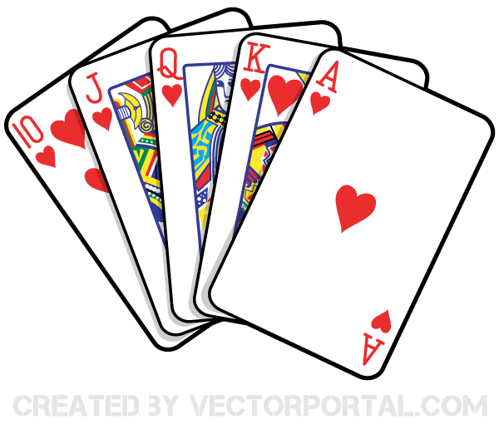  6:30 Puzzle Night |  | 23  10:30 Stretch & Strengthen (GB)  11:15 Ask the Rabbi  11:15 Relaxing Music  2:15 Bingo (GB)  3:30 Piano Concert with Tyslia  6:30 Hot Chocolate Cart |  | 24  10:30 Snoezelen (OK)  11:15 Relaxing Music  2:30 Baking Challah (OK)  3:15 Wine Time |  | 25  11:15 Montessori  3:15 Coffee Cart
26
10:30 Stretch & Strengthen (GB
2:15 Bingo (GB)
27  10:30 Stretch & Strengthen (GB)  11:15 Relaxing Music  2:15 Café Time (Bubbi Bessie’s)  3:30 Hello Visits  4:15 Montessori  6:30 Treat Cart | 28  10:30 Walking Club  11:15 Hello Visits  2:30 Pizza Making (GB)  4:15 Montessori  6:30 Dance Club with Kyle (2nd Floor) | 29  10:30 Book Club with Kyle (GD)  11:30 Zen Time  2:30 SPA afternoon  4:00 Montessori  6:30 Card Games (GB) | 30  10:30 Resident’s Council (OK)  10:45 Snoezelen (OK)  11:00 Food Committee (OK)  11:15 Ask the Rabbi  2:15 Bingo (GB)  3:30 Piano Concert with Tyslia  6:30 Tea & Chat (GB) |  | 31  10:30 Farmer’s Market Outing  2:15 Bingo (GB)  3:15 Wine Time

