1
10:15 Hello Visits
2:15 Bingo (GB)
2  10:30 Stretch & Strengthen  11:15 Montessori  2:30 Café Time (Bubbi Bessie’s Café)  6:30 Bowling Night | 3  10:30 Burlington Mall Outing  2:30 Art Afternoon (Goldblatt)  6:30 Move and Groove | 4  10:30 Book Club with Kyle (GB)  10:30 CCP Trip  2:30 Knit & Chat (1st Fl. Sunroom)  6:30 Card Games (GB) | 5  10:30 Snoezelen  11:15 Montessori  11:15 Ask the Rabbi  2:15 Bingo  3:30 Piano Concert with Tyslia  6:30 Hot Chocolate Cart | 6  10:30 Stretch & Strengthen  11:15 Zen Time  2:15 Bingo  3:15 Wine Time | 7  10:00 Ohev Zedek (Synagogue )  3:15 Montessori
8
10:30 Stretch & Strengthen (GB)
2:15 Combined Musical Memories
9  10:30 Snozelen  11:15 Montessori  2:30 Café Time (Bubbi Bessie’s Café)  6:30 Treat Cart | 10  10:30 Sew and Sew St. John’s (OK)  2:30 Musical Concert  6:30 Dance Club with Kyle | 11  10:30 Kehila Kids Hanukkah Program (Synagogue)  2:30 Card Making  6:30 Trivia Night | 12  10:30 Stretch & Strengthen  11:15 Ask the Rabbi  11:15 Montessori  2:15 Bingo  3:30 Piano Concert with Tyslia  6:30 Apple Cider Cart | 13  10:30 Farmer’s Market  2:15 Bingo  3:15 Wine Time | 14  10:30 Montessori  3:15 Coffee Cart
15
10:30 Hello Visits
2:00 Non-Denominational Services (Goldies)
16  10:30 Snoezelen  11:15 Relaxing Music  2:30 Café Time (Bubbi Bessie’s)  6:30 Bowling Night | 17  10:30 Stretch & Strengthen  11:15 Montessori  2:30 Movie Afternoon Theatre  6:30 Holiday Lights Outing | 18  10:30 Book Club with Kyle (GB)  11:30 Zen Time  2:30 Sing with Paula (Café)  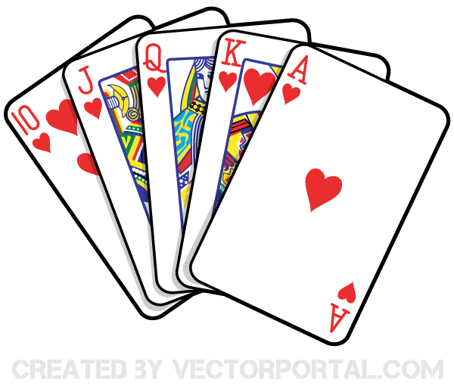  6:30 Puzzle Night | 19  10:30 Winter Cruise  11:15 Ask the Rabbi  2:15 Bingo  3:30 Piano Concert with Tsylia  6:30 Tea & Chat (Goldblatt) | 20  10:30 Bingo  11:15 Relaxing Music  2:30 Challah Baking  3:15 Wine Time | 21  10:30 Shabbat Services (Synagogue) followed by Kiddush Lunch (Goldies)  3:15 Montessori
22
10:30 Hello Visits
2:15 Bingo

23  10:30 Montessori  11:15 Relaxing Music  3:00 Holiday Open House  6:30 Historical Clip –Rebecca –Oak Knoll | 24  10:30 Combined Seated Zumba (OK)  2:30 Decorating for Hanukkah  6:30 Dance Club with Kyle | 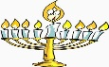  25 HANUKKAH  10:30 Hello Visits  Happy Birthday Mary!  11:00 Welcoming Hanukkah Program (Synagogue)  Noon Happy Birthday Mary (Zucker)  2:30 Decorating for Hanukkah  5:00 5:30 Lighting Hanukkah Candles  5/5:30 Hanukkah Dinner Resident Dining Rooms | 26 HANUKKAH  10:30 Travel Log with Rebecca –South Africa (Oak Knoll)  10:45 Montessori  11:15 Ask the Rabbi  2:30 Making Potato Lakes (GB)  5:00 5:30 Lighting Hanukkah Candles  6:30 Hot Chocolate Cart | 27 HANUKKAH  10:30 Stretch and Strengthen  11:15 Musical Memories  2:15 Bingo  3:15 Wine Time  5:00 5:30 Lighting Hanukkah Candles | 28 HANUKKAH  11:30 Hello Visits  3:15 Montessori
29 HANNUKKAH
11 30 Hello Visits
2:15 Bingo
5:00 5:30 Lighting Hanukkah Candles

30 HANUKKAH  10:30 Winter Cruise  2:15 Café Time (Bubby Bessie’s)  3:30 Hello Visits  5:00 5:30 Lighting Hanukkah Candles  6:30 Move and Groove | 31 HANUKKAH  10:30 Resident’s Council (OK)  10:45 Snoezelen  11:00 Food Committee (OK)  3:00 New Years Party with Elvis (Goldies)  5:00 5:30 Lighting Hanukkah Candles  6:30 Tea & Chat (GB) |   