 |  |  |  | 1  10:30 Bracelet Making Program (Art Room)  2:15 Bingo (WZ)  3:15 Wine Time | 2  10:15 Walking Club  3:15 Coffee & Tea Cart
3
10:15 Stretch & Strengthen (GB)
2:15 Bingo (GB)
4  10:30 Stretch & Strengthen  11:15 Montessori  2:30 Café Time (Bubbi Bessie’s Café)  6:30 Bowling Night | 5  10:30 Stretch & Strengthen  11:15 Story Reading  2:30 Snoezelen (OK)  3:30 Hello Visits  7:00 Dance Club with Kyle | 6  10:30 Book Club with Kyle (GB)  11:30 Walking Club  2:30 Knit & Chat (1st Fl. Sunroom)  6:30 Card Games (GB) | 7  10:30 Harley the Dog Visits (Theatre)  11:15 Ask the Rabbi  2:15 Bingo (WZ)  3:30 Piano Concert with Tsylia (Apt)  6:30 Tea and Chat | 8  10:30 Farmer’s Market Outing  2:15 Bingo (WZ)  3:15 Wine Time | 9  10:30 Hello Visits  3:15 Montessori
10
10:30 Walking Club
12:00 Happy Birthday Mikhail!!
2:15 Bingo (GB )
11 Remembrance Day  10:30 Remembrance Day Service (Synagogue)  2:30 Café Time (Bubbi Bessie’s Café)  6:30 Treat Cart | 12  10:30 Ola Bakery Outing  2:30 Cuban Jazz Concert (Goldies)  7:00 Dance Club with Kyle | 13  9:45 Fall Art Project with the Kehila Heschel Students (Bistro)  2:30 Travel Talk with Rebeca (OK)  3:00 Snozelen  6:30 Trivia Night (Sunroom) | 14  10:30 Snoezelen (OK)  11:15 Hello Visits  2:15 Bingo (WZ)  3:30 Piano Concert with Tsylia (APT)  6:30 Apple Cider Cart | 15  10:30 Bingo (weisz)  2:15 Challah Making (FDR)  3:15 Wine Time | 16  10:30 Shabbat Services (Synagogue) followed by Kiddush Lunch (Goldies)  2:30 Hello Visits
17
10:30 Walking Club
2:00 Non-Denominational Services (Goldies)
18  10:30 Stretch & Strengthen  11:15 Montessori  2:30 Café Time (Bubbi Bessie’s)  6:30 Bowling Night | 19  10:30 Snoezelen  2:30 Movie Afternoon Theatre  7:00 Dance Party with Kyle | 20  10:30 Fall Cruise with a Stop at Bennett’s Farm  2:30 Sing with Judy (Bubbi Bessie’s Cafe)  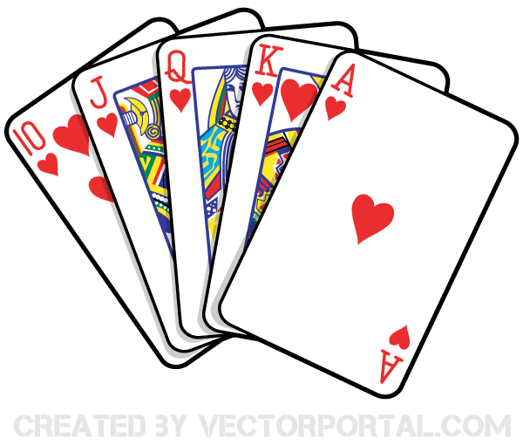  6:30 Card Games (GB) | 21  10:30 Art with Anita (Art Room)  12:00 Chinese Food Take Out (FDR)  2:15 Bingo (WZ)  3:30 Piano Concert with Tsylia (APT)  6:30 Tea & Chat (Goldblatt) | 22  10:30 Stretch & Strengthen (GB)  11:15 Story Reading  2:15 Bingo (WZ)  3:15 Wine Time | 23  10:30 Hello Visits  3:15 Montessori
24
10:30 Stretch & Strengthen (GB)
2:00 Grand Connection Part 1: “How to Make a Family Portrait with Hanoch Piven (Ruth Sherman Center) H.J.F
25  10:30 Montessori  11:15 Relaxing Music  2:15 Café Time (Bubby Bessie’s)  5:00 Making Pupusas (Goldies) | 26  10:30 King West Books Outing  2:30 Crosswords (GB)  3:30 Hello Visits  7:00 Dance Club with Kyle | 27  10:30 Book Club with Kyle (GB)  11:15 Zen Time  2:30 Historical Moments with Rebeca * Hamilton History  6:30 Puzzle Night (Sunroom) | 28  10:30 Stretch & Strengthen  11:15 Relaxing Music  11:15 Ask the Rabbi  2:15 Bingo (WZ)  3:30 Piano Concert with Tsylia (APT)  6:30 Hot Chocolate Cart | 29  10:30 Resident’s Council (OK)  10:30 Snoezelen (OK)  11:00 Food Committee (OK)  2:15 Bingo (GB)  3:15 Wine Time | 30  10:30 Hello Visits  2:15 Montessori

