Legend rooms
1st floor- OK (Oak Knoll)  EF (Effort Square)  2nd Floor- RC ( Raven cliffe)  Mf (Mayfair ) |  |  |  |  | 
 | 1 NATIONAL SENIOR’S DAY  10:30 Stretch & Strengthen (OK)  Noon Happy Birthday Patricia  2:30 Celebrate National Senior’s Day with Cake Bubbi Bessie’s Café  7 PM Hello Visits | 2 EREV Rosh Hashanah  10:30 Milli CRUISE  2:30 Setting up for Rosh Hashanah Dinner  5:00 Rosh Hashanah Dinner-OAK Knoll  5:30 Rosh Hashanah Dinner (Effort) | 3  Rosh Hashanah  10:00 Rosh Hasanah Service  10:45 Shofar  11:15 Ask the Rabbi  3:45 Rosh Hashanah Service | 4  Rosh Hashanah  10:00 Rosh Hashanah Service  10:45 Shofar  2:30 Coffee & Chat  6:30 Tea& Chat (OK) | 5  10:30 Walking Club  2:30 Hot Chocolate Cart
6
10:30 Combined Exercise
2:15 Bingo (RC)
7  10:30 Remembering October 7th Service (Synagogue)  2:30 Crossword (RC)  6:30 Trivia Night (Alcove) | 8  10:30 Walking Club  11:00 Relaxation time  Noon Happy Birthday Zelda  2:30 Snozelen  4:15 Montessori  6:30 Musical memories | 9  10:30 Spa Morning  2:15 Bubbi Bessie Café  3:30 Hello Visits  6:30 Movie Night | 10  10:30 Art With Anita (Art Room)  11:15 Ask the Rabbi  2:15 Bingo (EF)  3:30 Hello Visits | 11  10:30 Burlington Mall  2:15 Bingo (EF)  3:30 Wine Time  6:30 Kol Nidre Synagogue | 12  10:00 Yom Kippur Service Synagogue  2:15 Tea and Chat  3:45 Yizkor Service Synagogue
13
10:15 Walking Club
2:15 Bingo (RC)
14  10:30 Snozelen  11:15 Hello Visits  2:30 Relaxation Time (Snozelen)  6:30 Hot Chocolate With Sophia | 15  10:30 Wall Hanging Craft (OK)  2:00 Classical Pops (Goldies_  5:30 Soup Program | 16  10:30 Farmers Market  2:30 Decorating The Sukkah (SVO Garden)  6:30 Movie Night | 17 SUKKOT  10:30 Tea in the Sukkah  11:15 Ask the Rabbi  2:15 Travel Log with Rebecca (OK)  3:30 Hello Visits  5:00 Blessing the Lulav & Estrog | 18 SUKKOT  10:30 Tea in THE Sukkah  2:15 Snozelen  3:30 Wine Time  5:00 Blessing the Lulav & Estrog  6:30 Tea& Chat (OK) | 19 SUKKOT  10:30 Walking Club  2:15 Montessori
20
10:30 Hello Visits
2:00 Non Denominational Church Service
21 SUKKOT  10:30 Snozelen  11:00 Hello Visits  2:30 Pizza Making (Ok)  6:30 Movie Night | 22 SUKKOT  10:30 Stretch And strengthen Ok)  2:30 Movie Afternoon in the Theatre  4:15 Montessori  6:30 Treat and Great | 23 SUKKOT  10:30 Exercise Combined (RC)  11:30 Relaxation Music (Namaste)  2:30 Bubbi Bessie’s sing with Judy  6:30 Musical Memories (OK) | 24  10:00 Shemimi Atzeret( Synagogue )  11:15 Ask the Rabbi  2:15 Historical Facts (Rebecca) (OK)  3:45 Yizkor Service( Synagogue | 25  10;00 Simchat Service  11:00 Dancing with the Torah  2:30 Snozelen  3:30 Wine Time  6:30 Tea and Chat | 26 SUKKOT  10:00 Montessori  2:00 Hello Visits  27__________________________  10:30 Walking Club  2:15 Bingo (RC)
28  11:30 Dragon Court restaurant  2:30 Art in (RC)  4:15 Montessori  6:30 Treat and Great | 29  10:30 Stretch And strengthen  2:30 Rummoli (RC)  4:15 Montessori  6:30 Movie Night | 30  10:30 SPA with Vlad  11:15 Zen Time  1:00 Shalom Village Annual Tea (Reservation Required) (Goldies)  2:30 Cross Words (RC)  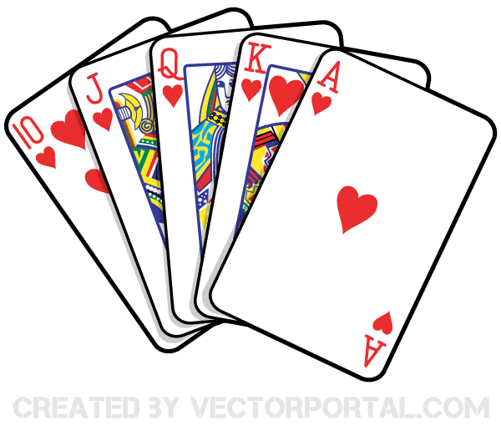  6:30 Travel Log | 31  10:30 Resident Council  11:00 Food Committee  11:00 Snozelen  2:15 Bingo (EF)  3:30 Hello Visits | You are cordially invited 43rd Annual Shalom Ladies Auxiliary Tea WED OCT 30 @ 1 PM are available at the front Lobby Reception please see Alex for details. Reservations required

