 | 1 National Senior’s Day  10:30 Tim Horton’s Cruise  2:30 Celebrate National Senior’s Day in the Café  6:30 Move and Groove | 2 Erev Rosh Hashanah  10:30 Book Club with Kyle (GB)  11:15 Relaxing Music  12:00 Happy Birthday Mary R  2:30 Setting up for Rosh Hashanah Dinner  5:00 Rosh Hashanah Dinner  5:30 Rosh Hashanah Dinner GD  7:00 Trivia Night (Sunroom) | 3 Rosh Hashanah  10:00 Rosh Hashanah Service (Synagogue)  10:45 Blowing of the Shofar  3:45 Rosh Hashanah Service  6:30 Cocktail Cart   | 4 Rosh Hashanah  10:00 Rosh Hashanah Service (Synagogue)  10:45 Shofar  2:30 Coffee & Chit Chat (WZ)  3:15 Wine Time   | 5  11:15 Walking Club  2:15 Montessori
6
10:15 Stretch & Strengthen
2:15 Bingo (GB)
7  10:30 Remembering October 7th Service (Synagogue)  2:30 Café Time (Bubbi Bessie’s Café)  6:30 Musical Memories | 8  10:30 Burlington Mall Outing  2:30 Spa Afternoon  3:30 Hello Visits  6:30 Move and Groove | 9  10:30 Snoezelen (OK)  11:30 Walking Club  2:30 Knit & Chat (1st Fl. Sunroom)  6:30 Card Games (GB) | 10  10:30 Visit with Harley (Theatre)  10:30 Ask the Rabbi  2:15 Bingo (WZ)  3:30 Piano Concert with  Tsilya (Apt)  6:30 Cross Words (GB) | 11  10:30 Stretch & Strengthen  11:30 Montessori  2:15 Bingo (WZ)  3:15 Wine Time  6:30 Kol Nidre Service (Synagogue) | 12 Yom Kippur  10:00 Yom Kippur Service (Synagogue)  2:15 Tea & Chat (GB)  3:45 Yizkor Service (Synagogue)
13
10:30 Hello Visits
2:15 Bingo (GB)
14  10:30 Stretch & Strengthen  11:15 Zen Time  2:30 Café Time (Bubbi Bessie’s Café  6:30 Bowling Night | 15  10:30 Wall Hanging Craft (GB)  2:00 Classical Pops (Goldies)  5:30 Soup Program (Goldie’s) | 16  10:30 Farmer’s Market Outing  2:30 Decorating the Sukkah (SVO Garden)  6:30 Trivia Night (Sunroom) | 17 Sukkot  10:30 Tea in the Sukkah (SVO Garden)  11:15 Ask the Rabbi  2:30 Snoezelen (OK)  2:30 Travel Log with Rebecca (OK)  5:00 Blessing the Lulav & Etrog  6:30 Apple Cider Cart | 18 Sukkot  10:30 Tea in the Sukkah (SVO Garden)  2:30 Story Reading  3:15 Wine Time  5:00 Blessing the Lulav & Etrog | 19 Sukkot  10:30 Hello Visits  2:30 Montessori
20 Sukkot
10:30 Hello Visits
2:00 Non-Denominational Services (Goldies)
21 Sukkot  10:30 Walking Club  11:15 Relaxing Music  2:30 Café Time (Bubbi Bessie’s)  6:30 Spa Evening with Adrii | 22 Sukkot  10:30 Hello Visits  11:30 West end Diner Outing  2:30 Movie Afternoon (Theatre)  6:30 Dance Party with Kyle | 23 Sukkot  10:30 Book Club with Kyle (GB)  11:00 Montessori  2:30 Sing with Judy (Bubbi Bessie’s Cafe)  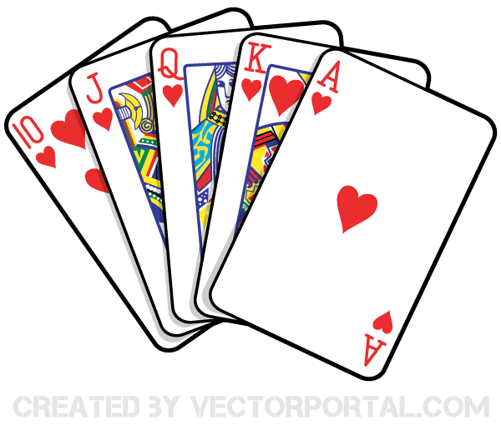  6:30 Card Games (GB) | 24  10:00 Shemini Atzeret Service (Synagogue)  2:15 Snoezelen (OK)  2:15 Historical Facts with Rebecca (Ok)  3:45 Yizkor Service (Synagogue)  6:30 Tea & Chat (Goldblatt) | 25  10:00 Simchat Service (Synagogue)  11:00 Dancing with the Torah  2:30 Story Reading  3:15 Wine Time | 26  10:30 Hello Visits  2:15 Montessori
27
10:30 Stretch & Strengthen
2:15 Bingo (GB)
28  10:30 Stretch & Strengthen (GB)  11:15 Relaxing Music  2:15 Café Time (Bubby Bessie’s)  6:30 Trivia Night (Sunroom) | 29  10:30 Stretch & Strengthen (GB)  11:15 Relaxing Music  2:30 Games Afternoon (GB)  6:30 Move and Groove | 30  10:30 Book Club with Kyle (GB)  11:15 Zen Time  1:00 Shalom Village Annual Tea (Reservation Required) (Goldies)  2:30 Knit & Chat (Sunroom)  6:30 Travel Log | 31  10:30 Resident’s Council & Food Committee (OK)  10:45 Snoezelen  11:15 Ask the Rabbi  2:15 Bingo (WZ)  3:45 Piano Concert with Tsilya (Apt  6:30 Hot Chocolate Cart | You are cordially invited to the 43rd Annual Shalom Ladies Auxiliary Tea WED OCT 30 @ 1 PM. Tickets are available at the front Lobby Reception please see Alex for details. Reservations required.

