Legend Rooms  1st floor  (OK) Oak Knoll  (EF) –Effort Square  2nd Floor  (RC) –Ravencliffe  (MF) Mayfair  FDR Family Dining Room | 1  NATIONAL SENIOR’S DAY  10:30 Stretch & Strengthen Alcove  2:30 Celebrate National Senior’s Day with Cake  7 PM Hello Visits | 2 EREV Rosh Hashanah  10:30 Walking Club  2:30 Setting up for Rosh Hashanah Dinner  5:00 Rosh Hashanah Dinner-Ravenscliffe  5:30 Rosh Hashanah Dinner (Mayfair) | 3 Rosh Hashanah  10:30 Readings for Rosh Hashanah  1 PM Blowing the Shofar with Rabbi  2:30 Short Stories Ravenscliffe  3:30 Short Stories Mayfair   | 4 Rosh Hashanah  10:30 Hello Visits  1 PM Blow the Shofar  2:30 Coffee & Chat  7:15 Hello Visits | 5  11:30 Walking Club  3:00 Hot Chocolate
6
10:30 Combined Exercise
2:15 Bingo (RC)
7  10:30 Remembering October 7th Service (Synagogue)  2:30 Crossword (RC)  3:45 Montessori with Rebeca  6:30 Trivia Night (Alcove) | 8  10:30 Walking Club  11:00 Relaxation time  2:30 Snoezelen  4:15 Montessori  6:30 Musical memories | 9  10:30 Spa Morning  2:15 Bubbi Bessie Café  Noon Happy Birthday NIcole  3:30 Hello Visits  6:30 Movie Night | 10  10:30 Art With Anita (Art Room)  11:15 Ask the Rabbi  2:15 Bingo (RC)  3:30 Hello Visits | 11  10:30 Burlington Mall  2:15 Bingo (RC)  3:30 Wine Time  6:30 Kol Nidre Synagogue | 12  10:00 Yom Kippur Service( Synagogue )  2:15 Tea and Chat  3:45 Yizkor Service (Synagogue)
13
10:15 Walking Club
2:15 Bingo (RC)
14  10:30 Snoezelen  11:15 Hello Visits  2:30 Relaxation Time (Alcove)  6:30 Hot Chocolate with Sophia | 15  10:30 Wall Hanging Craft (OK)  2:00 Classical Pops (Goldies)  3:30 Montessori  5:30 Soup Program | 16  10:30 Farmers Market  2:30 Decorating The Sukkah (SVO Garden)  6:30 Movie Night | 17 SUKKOT  10:30 Tea in the Sukkah  11:15 Ask the Rabbi  2:15 Travel Log with Rebeca (OK)  3:30 Hello Visits  5:00 Blessing the Lulav & Estrog | 18 SUKKOT  10:30 Tea in the Sukkah  2:15 Snoezelen  3:30 Wine Time  5:00 Blessing the Lulav & Estrog  6:30 Tea& Chat (OK) | 19 SUKKOT  11:30 Walking Club  3:15 Montessori
20 SUKKOT
11:30 Hello Visits
2:00 Non-Denominational Church Service (Goldie’s)
21 SUKKOT  10:30 Snoezelen  11:00 Hello Visits  2:30 Pizza Making (OK)  6:30 Apple Cider Cart | 22 SUKKOT  10:30 Stretch And strengthen  2:30 Movie Afternoon in the Theatre  6:30 Tea & Chat (OK) | 23 SUKKOT  10:30 Exercise Combined (RC)  11:30 Relaxation Music (Namaste)  2:30 Sing with Judy Bubbi Bessie’s  6:30 Musical Memories (OK) | 24  10:00 Shemimi Atzeret( Synagogue )  11:15 Ask the Rabbi  2:15 Historical Facts (Rebecca) (OK)  3:45 Yizkor Service( Synagogue ) | 25  10:00 Simchat Service  11:00 Dancing with the Torah  2:30 Snoezelen  3:30 Wine Time  6:30 Tea and Chat | 26  11:30 Montessori  3:00 Hello Visits  27_________________________  10:30 Walking Club  2:15 Bingo (RC)
28  11:30 Dragon Court restaurant  2:30 Art in (RC)  4:15 Montessori  6:30 Treat and Great | 29  10:30 Stretch And strengthen (RC)  2:30 Rummoli (RC)  4:15 Montessori  6:30 Movie Night (OK) | 30  10:30 SPA with Rebecca  11:15 Zen Time  1:00 Shalom Village Annual Tea (Reservation Required) (Goldies)  2:30 Cross Words (RC)  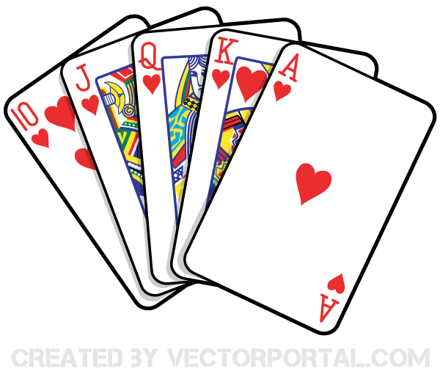  6:30 Travel Log | 31  10:30 Resident Council  11:00 Snozeloen  11:00 Food Committee  2:15 Bingo (RC)  3:30 Hello Visits | You are cordially invited 43rd Annual Shalom Ladies Auxiliary Tea WED OCT 30 @ 1 PM are available at the front Lobby Reception please see Alex for details. Reservations required

