1 Canada Day  10:30 Stretch & Strengthen  11:15 Story Reading ( Sunroom)  3:00 Canada Day Celebration ft. The Escapades (SVO Garden)  6:30 Popsicle Cart | 2  10:30 Barley the Dog Visits  11:15 Relaxing Music  2:30 Outdoor Time  6:30 Move and Groove | 3  10:30 Book Club with Kyle (GB))  11:15 Walking Club  2:30 Popsicles in the Garden  6:30 Card Games (GB) | 4  10:30 Snoezelen Room sv2  10:30 Ask the Rabbi  11:15 Zen Time (Sunroom)  2:15 Bingo (WZ)  3:30 Montessori  6:30 Outdoor Time | 5  10:30 Two Cougars & A Cafe Outing  2:15 Bingo (WZ)  3:15 Wine Time | 6  10:30 Walking Club  2:15 Ice Cream Cart
7
11:30 Hello Visits
2:15 Bingo (WZ)
8  10:30 Stretch & Strengthen (GB)  11:30 Garden Lunch (Goldblatt)  2:15 Café Time (Bubbi Bessie’s Café)  6:30 Outdoor Time (Combined) | 9  10:30 Outdoor Time  11:15 Relaxing Music  2:30 Root Beer Floats  3:30 Hello Visits  6:30 Move and Groove | 10  10:30 Book Club with Kyle  10:30 Harley the Dog Visits  1:30 CCP Outing  3:15 Story Reading (Story Time)  6:30 Trivia Night (Sunroom) | 11  10:30 Farmer’s Market Outing  10:30 Ask the Rabbi  2:15 Bingo (WZ)  3:30 Montessori  6:30 Cocktail Cart | 12  10:30 Snoezelen Room SV2  2:15 Bingo (WZ)  3:15 Wine Time   | 13  10 :15 Walking Club  2 15 Montessori
14
11:30 Hello Visits
2:00 Non-Denominational Services (Goldie’s)
15  10:30 Snoezelen (SV2)  Noon Happy Birthday Mary Anne  2:00 Ancaster Ice Cream Parlor Outing  3:30 Story Reading (Sunroom)  6:30 Treat Cart | 16  10:30 Barley the Dog Visits  11:15 Relaxation Time (Sunroom)  2:30 Combined Movie Screening (Classic Theatre)  6:00 Soup Making with Aurica (Goldie’s) | 17  10:30 Book Club with Kyle (GB)  11:15 Walking Club  2:30 Sing with Judy (Café)  6:30 Card Games (GB) | 18  10:30 Snoezelen SV2  10:30 Ask the Rabbi  2:15 Bingo (WZ)  3:30 Montessori  6:30 Outdoor Time | 19  10:30 Montessori  11:30 Weisz Garden Lunch  2:15 Bingo (WZ)  3:30 Wine Time | 20  11:30 Hello Visits  2:15 Montessori
21
11:30 Stretch & Strengthen (GB)
2 :15 Bingo (WZ)
22  10:30 Burlington Mall Outing  2:30 Outdoor Time  6:30 Bowling Night | 23  10:30 Barley the Dog Visits  2:30 Knit & Chat (1st Floor Sunroom)  3:30 Story Reading (Sunroom)  6:30 Men’s Club: Pool Night (SV2 Apt) | 24  10:30 Book Club with Kyle (GB)  11:15 Walking Club  2:30 Sing with Cantor Paula (Bubbi Bessie’s Café)  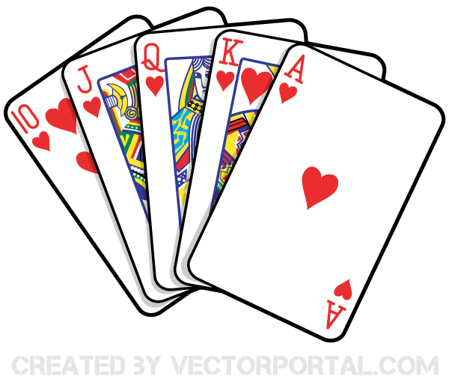  6:30 Trivia Night (GB) | 25  10:30 Snoezelen Room Combined (OK)  10:30 Ask the Rabbi  2:15 Bingo (WZ))  3;30 Montessori  6:30 Outdoor Time | 26  10:30 Outdoor Time  11:30 Zucker Garden Lunch  11:15 Relaxing Music (Sunroom)  2:15 Bingo (WZ)  3:30 Wine Time | 27  10:30 Shabbat Service (Synagogue) following a Kiddush lunch) Goldie’s)  2:00 Montessori
28
10:30 Walking Club
2:15 Bingo (WZ)
29  10:30 Walking Club  11:30 Gould Garden Lunch  2:30 Café Time (Bubbi Bessie’s Café)  6:30 Outdoor Time Combined)   | 30  10:30 Resident’s Council Meeting (OK)  11:15 Barley the Dog Visits  2:30 Walking Club  3:30 Zen Time (Sunroom)  6:30 Move & Groove (2nd floor) | 31  10:30 SVO Summer Cruise  2:30 SV0 Garden Time and Lemonade  6:30 Outdoor Time combined   | 
Legend:
SVO

